Clark Neighbors Food Project
You want to help, and we make it easy … one Green Bag at a time!
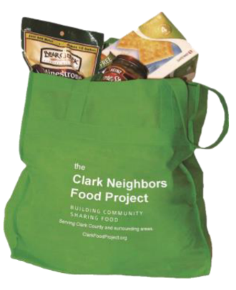
Hi, I’m your neighbor _______________________________________

I am a Neighborhood Coordinator with the Clark Neighbors Food Project, a wonderful community program that makes it easy to keep our local food pantries going strong all year with a steady supply of food.

The economy is hitting many families hard in our community and a growing number of people are now food insecure. Our food pantries are doing their best to keep up with the demand, but they need our continued support.

We would really love it if you could join us. Here’s how it works:

Step 1: Contact me by phone, email or text to sign up, and I’ll leave a Green Bag on your porch with information on the types of food most needed.

Step 2: Each week, you buy a few extra non-perishable food items when you get groceries and then store them in your Green Bag.

Step 3: On the second Saturday of even months, place your filled Green Bag on your front porch by 9:00 am and I'll swing by shortly afterward to pick it up. I will leave an empty Green Bag for the next food collection. It’s that simple!

Step 4: I will take all the food collected from our neighborhood directly to one of our Clark County approved donation sites where it will be made available to our hungry neighbors.

Together we can build resilience against hunger in our community and help our neighbors in need. I hope you will join us!

Name:
Phone Number:
Email:
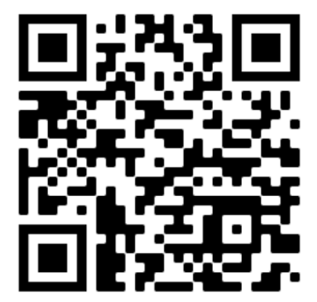
To Lean more:
- Scan the QR code to check out a helpful and informative video about the Clark Neighbors Food Project
- Our website: www.clarkfoodproject.org
- Facebook: www.facebook.com/clarkfoodproject

