**Clark Neighbors Food Project**

You want to help, and we make it easy … one Green Bag at a time!

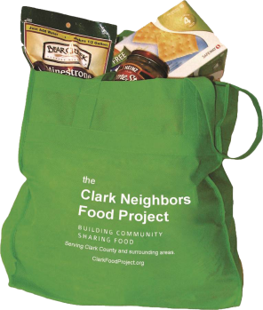***Hi, I’m your neighbor ____________ (name) and I just became a Neighborhood Coordinator with the Clark Neighbors Food Project, an amazing community program that makes it easy to keep our local food pantries going strong all year with a steady supply of food.***

*COVID is hitting more and more families hard in our community and a growing number of people are now food insecure. Our food pantries are doing their best to keep up with the demand, but they need our continued support.*

*Our neighborhood is just getting started with the* ***Clark Neighbors Food Project****, and we would really love it if you could join us.*

**Here’s how it works:**

Step 1: Contact me by phone, email or text to sign up, and I’ll leave a Green Bag on your porch with information on the types of food most needed.

Step 2: Each week, you buy a few extra non-perishable food items when you get groceries and then store them in your Green Bag.

Step 3: On the second Saturday of even months, simply place your filled Green Bag on your front porch by 9 am and I'll swing by shortly afterward to pick up your bag; I’ll then leave an empty Green Bag for you to use for the next food collection. It’s that simple!

**The next food collection date is Saturday, _________________.**

Step 4: I will then take all the food collected from our neighborhood directly to [pantry name, website], where it will be made available to our hungry neighbors in [area].

***Together we can build resilience against hunger in our community and help our neighbors in need. I hope you will join us!***

Your neighbor at _____________________ (your address)

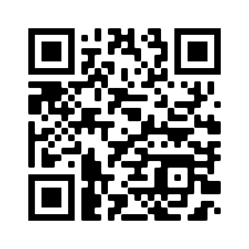

**Your Name**

Neighborhood Coordinator

Clark Neighbors Food Project

Your phone

Your email

**Check us out at:**

[www.clarkfoodproject.org](http://www.clarkfoodproject.org/)

[www.facebook.com/clarkfoodproject](http://www.facebook.com/clarkfoodproject)

PS – Scan the QR code to check out a helpful informational video about the Clark Neighbors Food Project – <https://clarkfoodproject.org/79-2>